**CHAPTER 6: INTERFACE AND REPORTS**

We created a cloud base web interface to access our database. Next we list the technologies use to build the interface:

* Amazon EC2
* Visual Studio 2015 Community Edition
* Visual Basic
* Bootstrap

**INTERFACE URL:**

<http://ec2-35-161-120-34.us-west-2.compute.amazonaws.com/WebSite2/Public/Default.aspx>

In this website you are presented with a left menu containing different reports obtained by predefined queries. To make the access to these queries faster, we decided to create views.

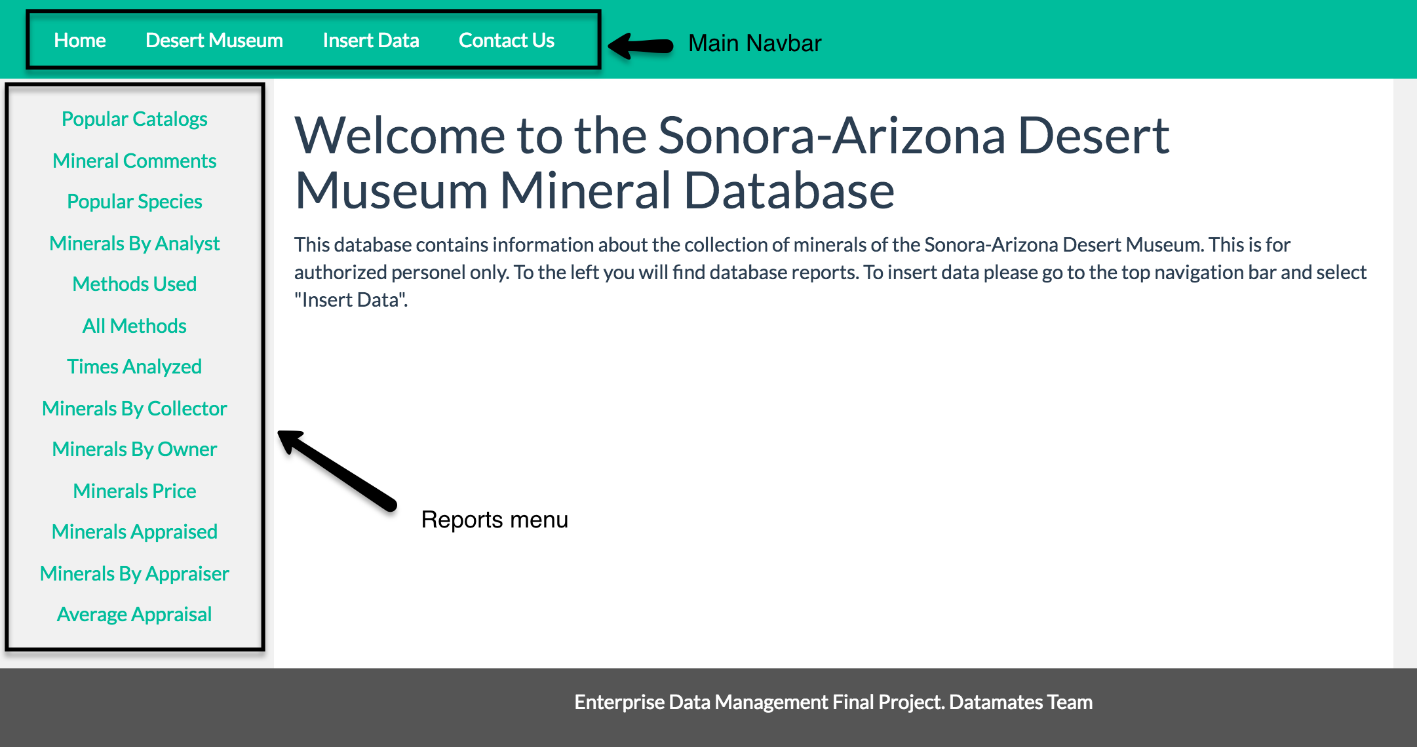

To execute the queries for the reports, you need to select the report that you are interested in the reports menu.

Here are some examples:

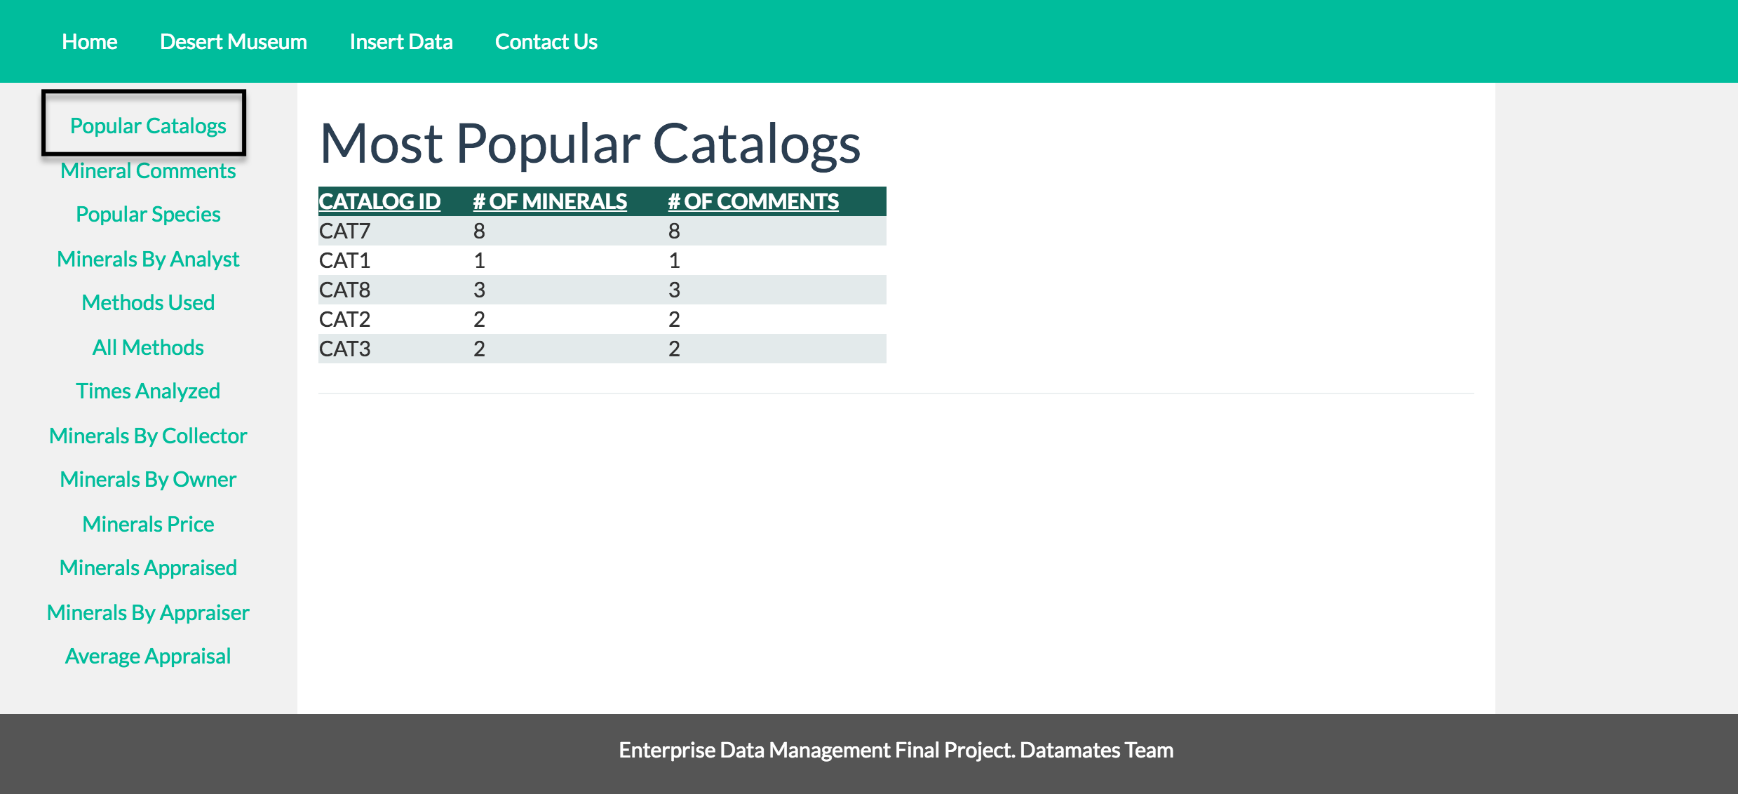

Query for Most Popular Catalogs:

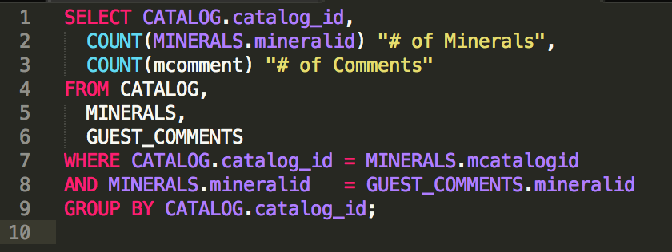

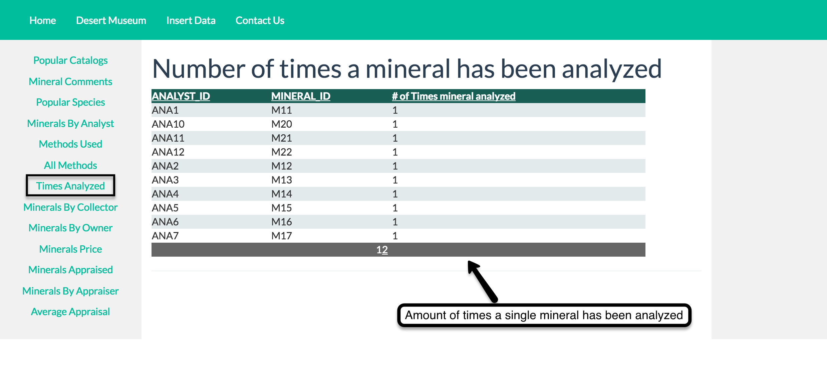

Query for number of times a mineral has been analyzed:

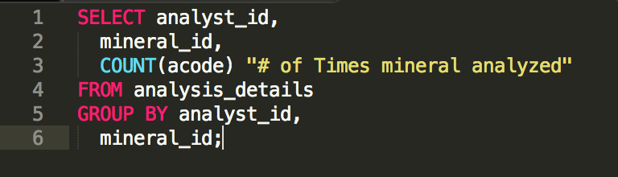

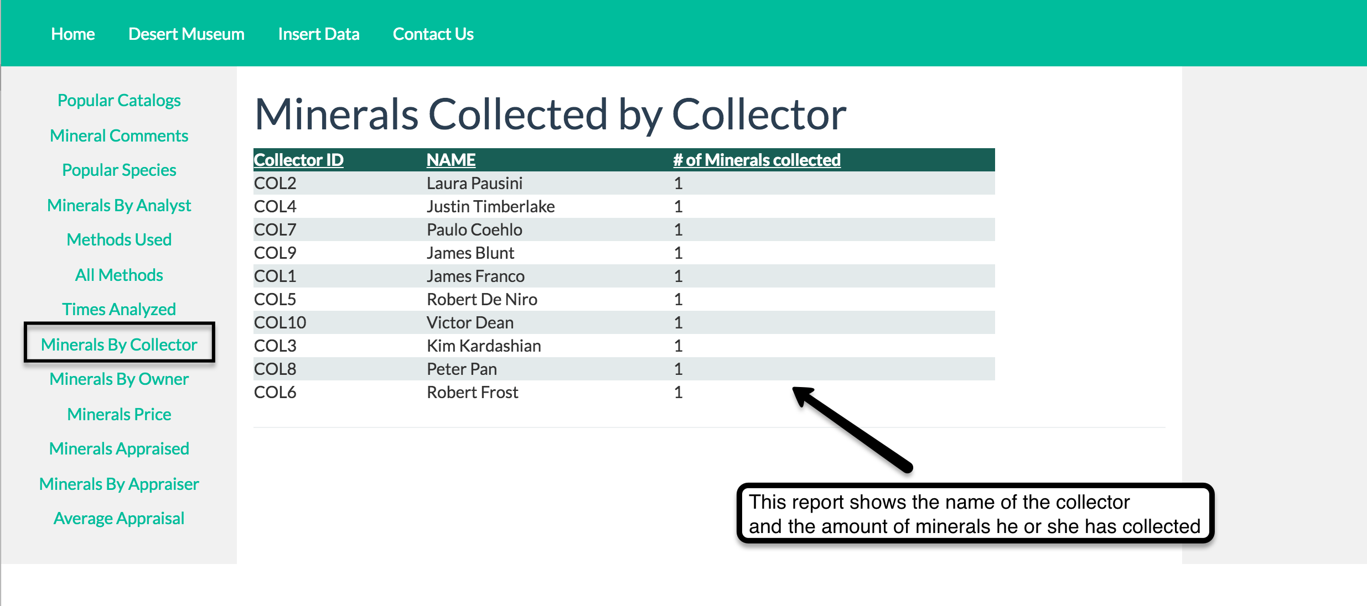

Query for Minerals Collected by Collector

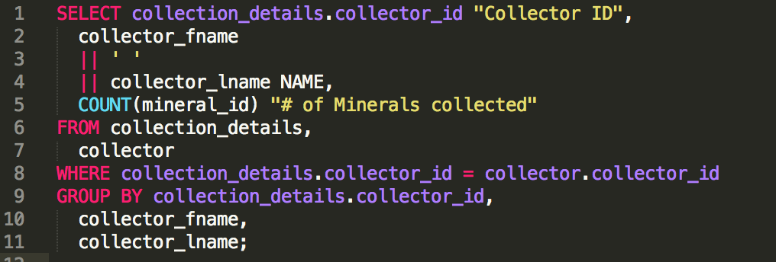

**INSERTS, DELETES AND UPDATE**

Our web interface allows you to perform some DML commands, for this you need to go to the “Insert Data” section, located in the main navbar.

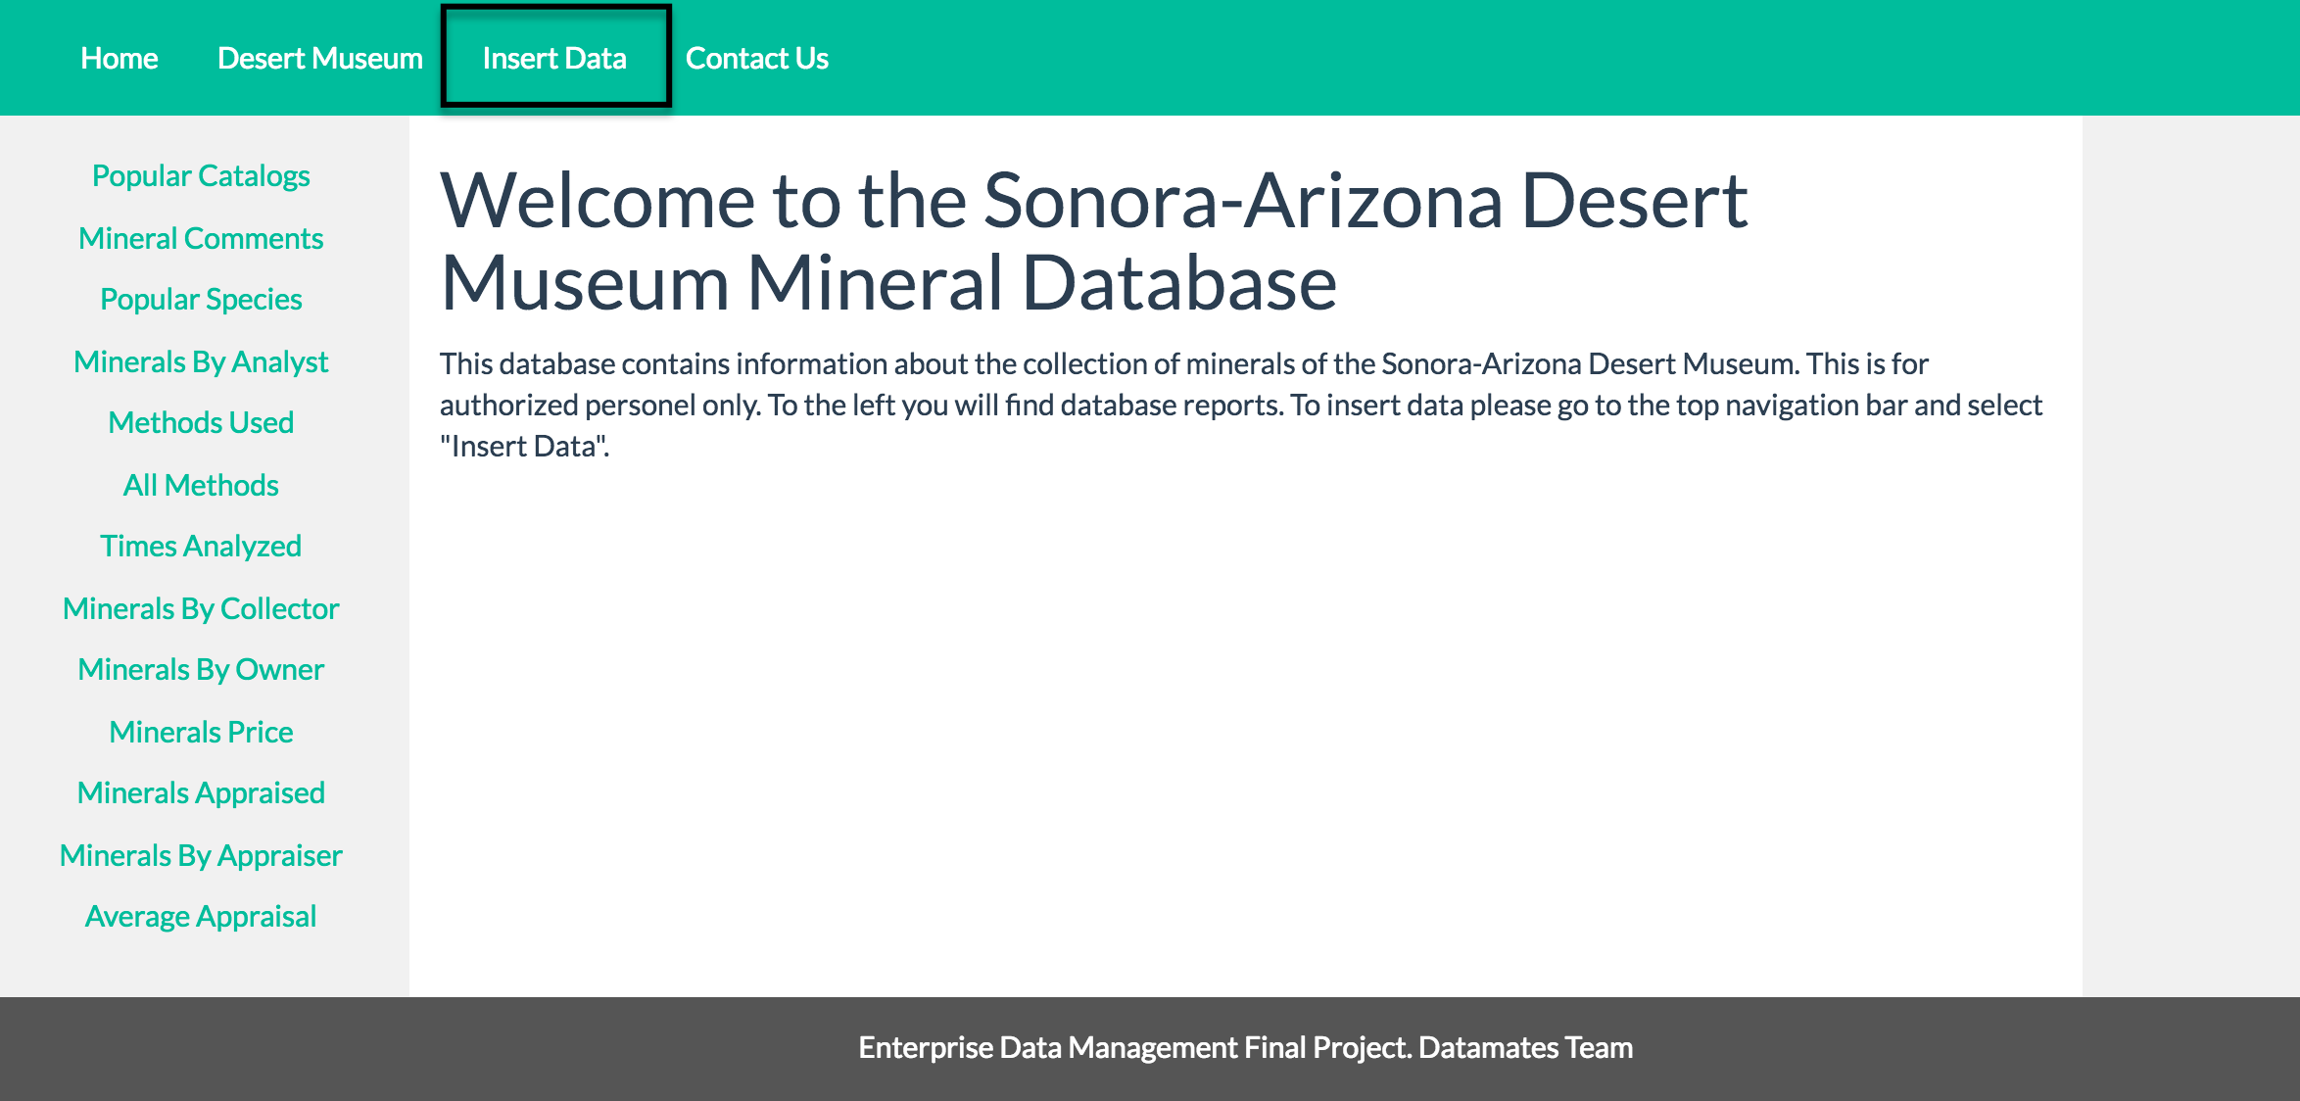

Once you click on “Insert Data” instead of seeing the reports option, you will see the tables available to modify. These tables are Minerals, Species, Analyst, Owner, Catalog, Collector and Appraiser.

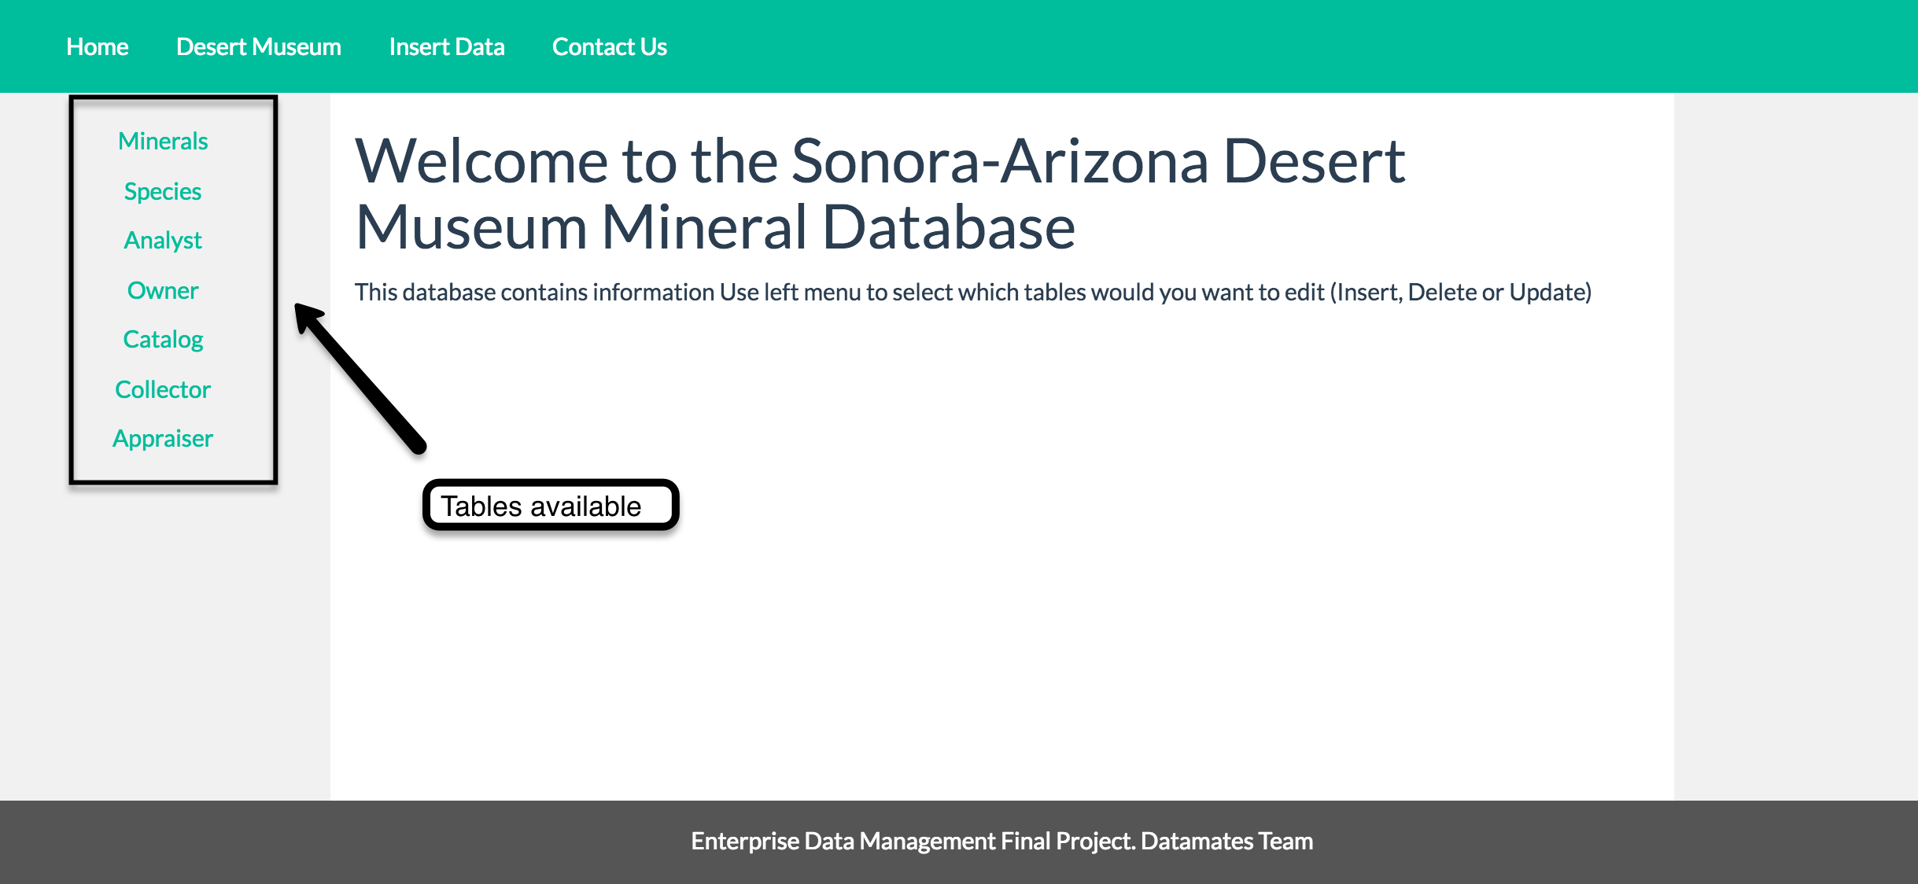

When you click on one of these options, you will be presented with a form, and a Grid View. The form will allow you to Insert data, from the Grid View you will be able to Delete and Update.

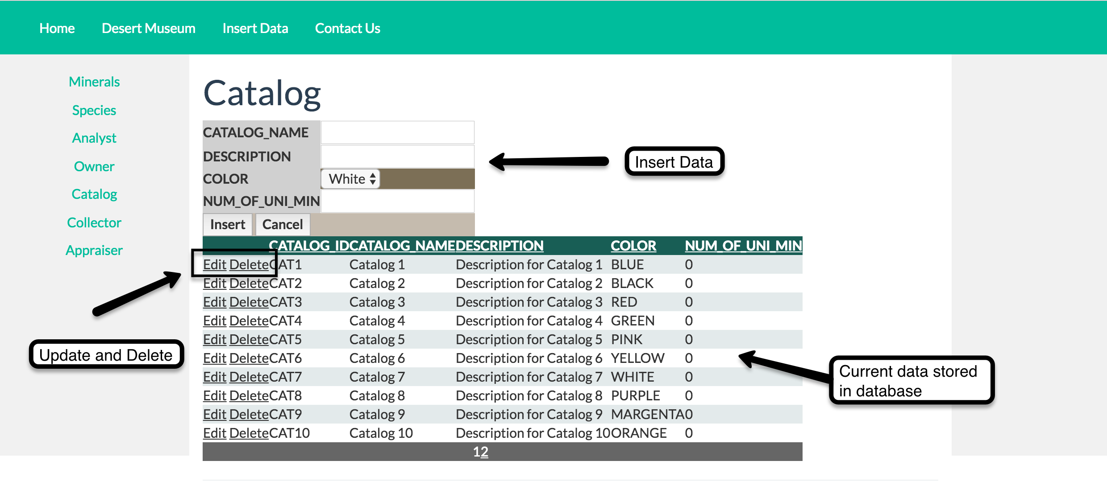

Since in some tables we have data constraints, we decided to implement dropdown boxes so the user can insert the correct values.

**HOW TO INSERT**

Insert data in the form and click Insert. Select Cancel if you no longer want to insert data.

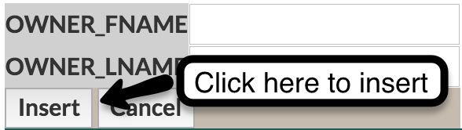

**HOW TO DELETE.**

Click the delete option next to the row of data you wish to delete.

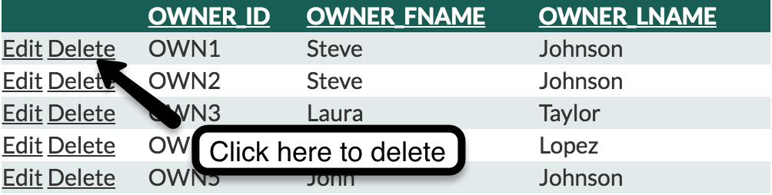

**HOW TO UPDATE.**

Select a row and click on “Edit”. The row will convert into a text form format. Write your changes and click “Update”.

